Webproject EA 2018

Chiu Ka Yau(170231389)

Wu kwok Wang(170160546)

Chen xuchu(170146681)

Our website is talk about sport car. Is let people buy cars anytime, anywhere, understand brands, exchange ideas and share ideas.

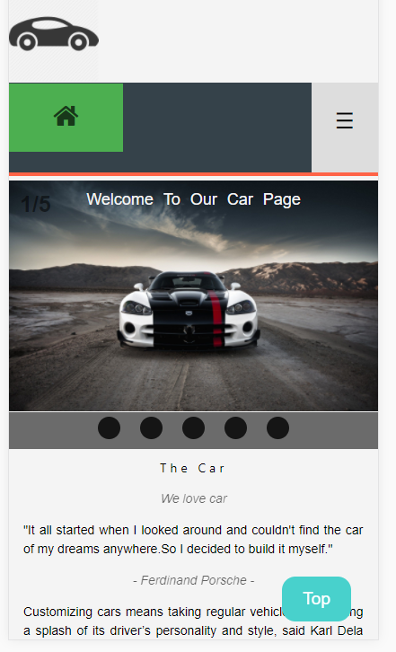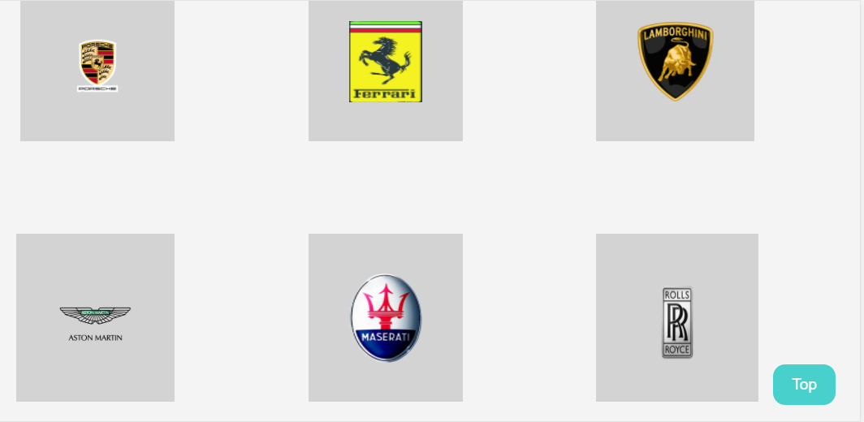

As you seen, our website is link to our other html, in the header,we use @media screen and (max-width: 750px) {} to hide the header button of mobile website. Also, the photo has link to the other External website.

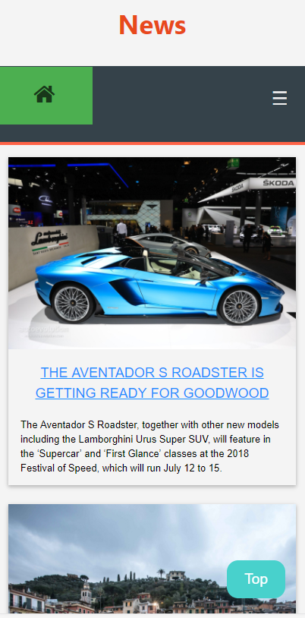

This is News page. The page is post the News to customers. Also have link to other website to how more information.

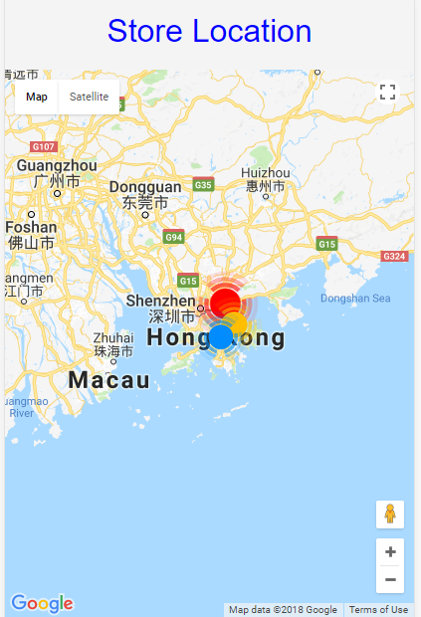

The point is tell customers our company location

The code about the GPS.html

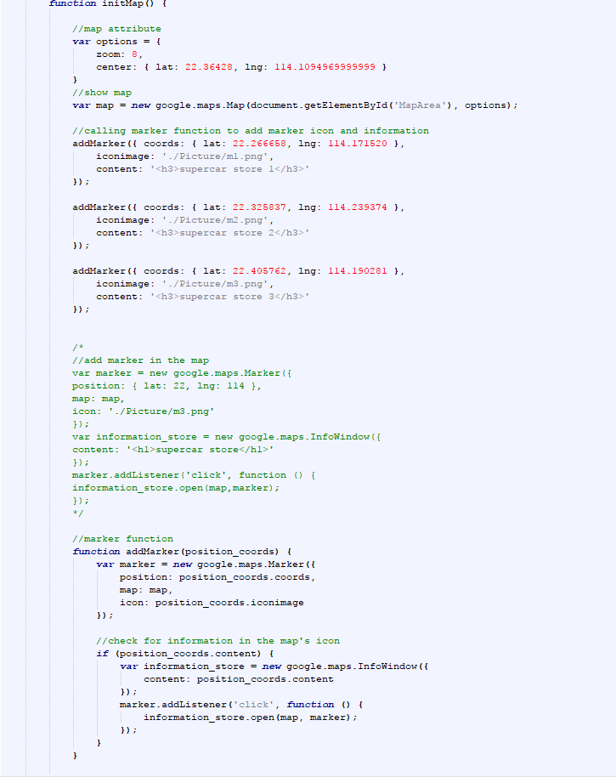

We have offer a the form to login and apply the account.

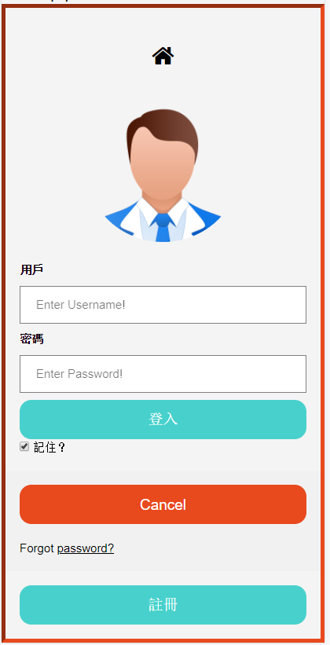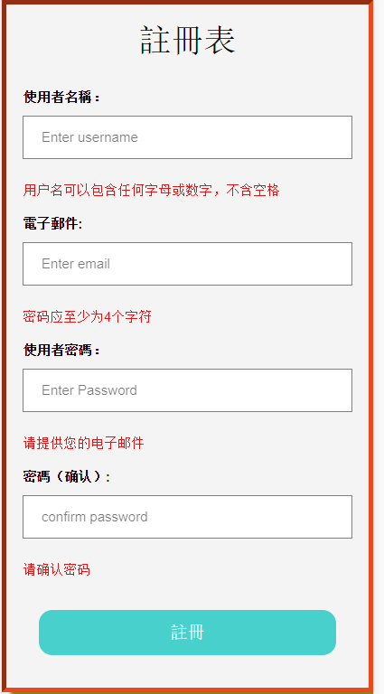

As you seen. This is the apply form. You can fill in the form to apply a account.

About the code of form PHP

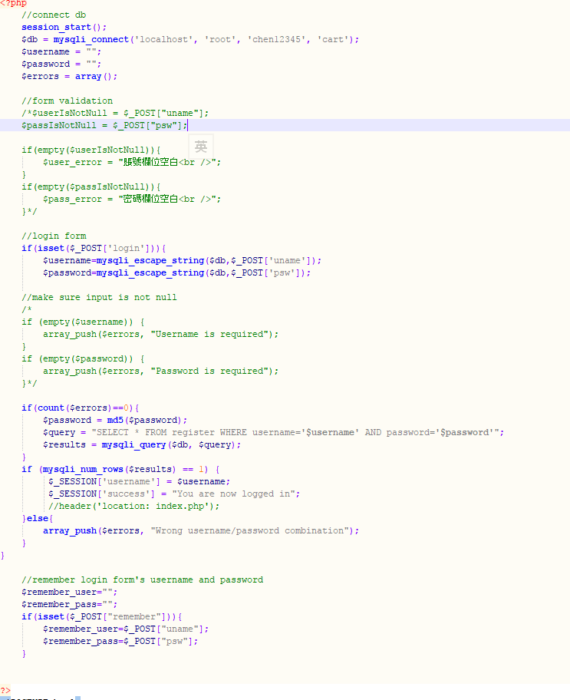

The code about the apply form of PHP

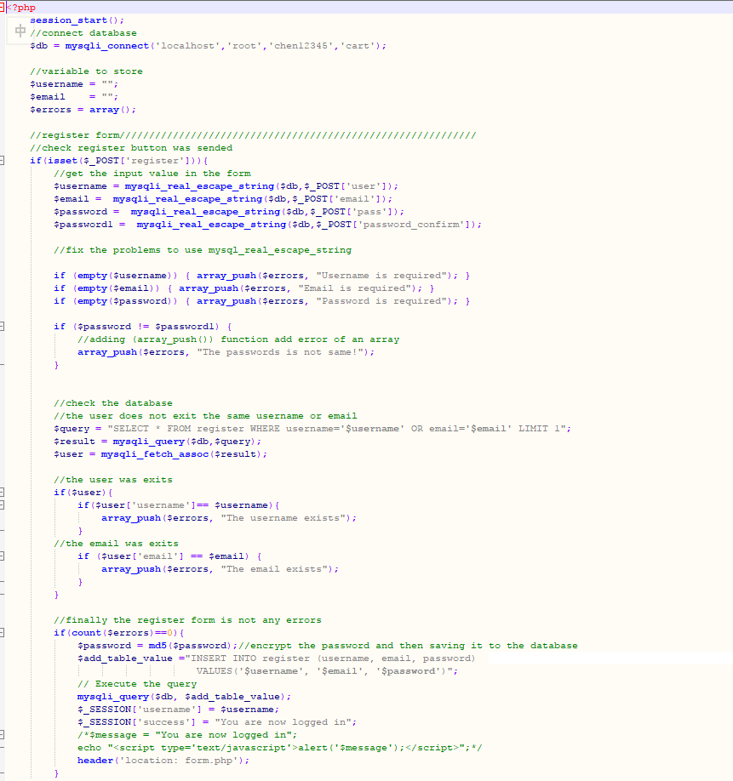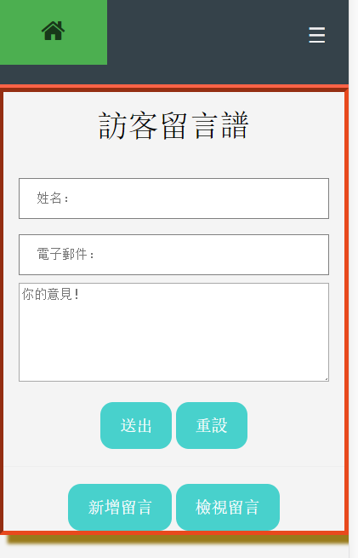

The user can express their comments to us. And send it, and then you can see the comment.



Also, you can see other people’s comments.

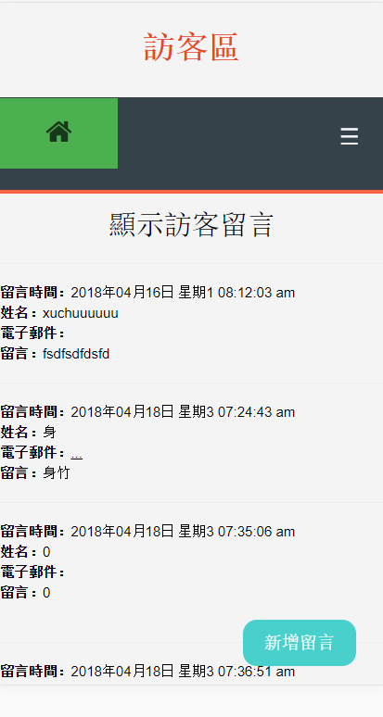

Shopping cart , add to cart ,the data will show product detail and button checkout. Its sql filename is products.sql.

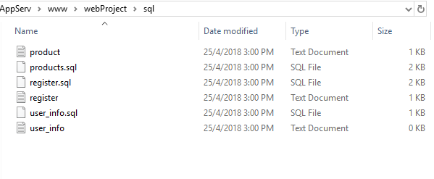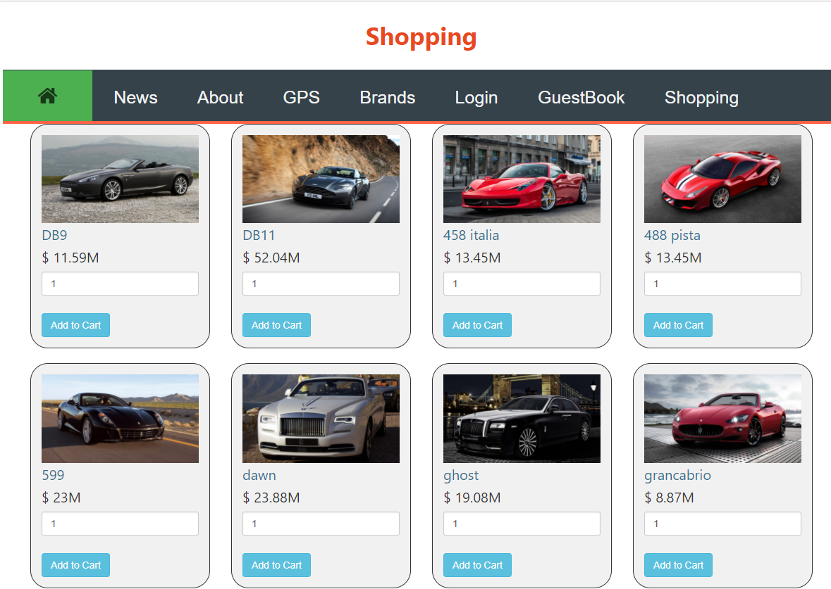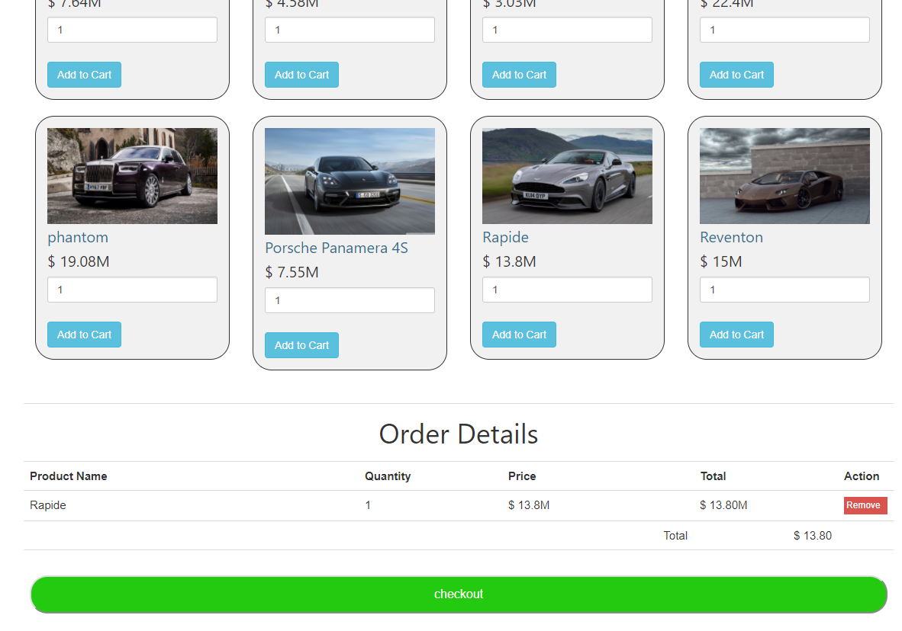

You can checkout to fill in the form of the detail. And then order place.

